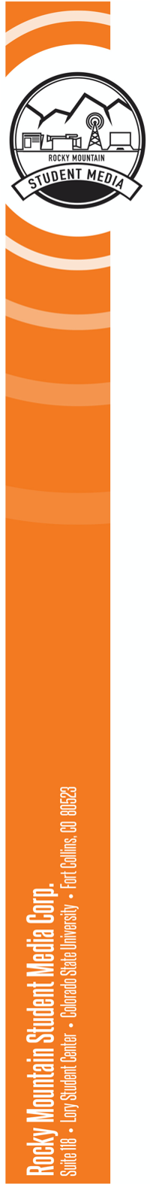

**The Rocky Mountain Collegian   
Illustration Editor**

The Illustration Editor is a leader who oversees the operations of the Collegian’s illustration team. The Illustration Editor is excited about design, is actively engaged in the overall quality of the graphics and illustrations, and is able to meet tight deadlines. The position **requires a commitment of 8 hours per week of work-related duties** and **varying summer hours**. This is a single position.

This position is a one-year appointment, contingent upon performance review or rehiring practice at the jurisdiction of the Editor in Chief.

The ideal candidate possesses the following qualities:

* Thinks ahead and plans for success.
* Highly skilled illustrator
* Strong communication skills and an ability to make decisions under pressure.
* Effectively balances time commitments outside of work.
* Has a strong understanding of design principles.
* Highly skilled in Adobe Creative Cloud with advanced skills specifically in Adobe Illustrator, Adobe InDesign and Adobe Photoshop. Other programs such as Procreate or Adobe Fresco are a plus.
* Creative and willingness to try new things in newspaper illustrations.
* Responsive to Editorial changes as content changes frequently.
* Approaches problems and challenges with an open mind.
* Strong organization skills and an ability to coordinate a team of illustrators.
* Has a basic understanding of journalistic ethics and its application to design.
* Prioritizes teamwork to maintain an inclusive and professional culture on the desk.
* A self-starter with initiative, drive and commitment.

**Main Responsibilities**

* Creates illustrations for the paper and takes responsibility for all illustrations.
* Works with the Print Editors to make decisions on the cover design or illustration.
* Plans ahead for change, and frequently communicates with other editors to anticipate problems.
* Communicates frequently with managing editors and the copy chief about problems that could disrupt production.
* Pitches new and creative ideas to engage with the readers through print and digital design.
* Be able and willing to produce quality graphics and infographics when asked on a deadline.
* Responds quickly to visual requests from desks and monitors upcoming content for what illustrations could be created.
* Co-directs the team of page designers and illustrators with Print Editor.



**Managerial Responsibilities**

* Teaches and coaches illustrators.
* Responds to visual requests and assigns illustration assignments.
* Maintains a good relationship with the graphic design program to encourage student engagement.
* Frequently attends budget meetings to keep up with content and necessary illustrations.
* Completes payroll for illustrations team.
* Encourages and nurtures new illustrators and coaches skills.
* Corrects design errors as they arise as a result of editorial decisions or copyediting.
* Keeps the illustrators accountable for deadlines
* Directs the illustrators to create a product that adheres to consistent brand decisions.
* Holds a weekly illustration desk meeting for assignments
* Communicates with the Digital & Social Editor, Print Editor and Photo team to decide what stories need to be illustrated
* Holds weekly office hours to be accessible to illustrators
* Attends a weekly all-staff content meeting.

**Compensation**: Compensation will be $15 per hour. Employees are encouraged to apply for University work study. Employee Benefit information through Colorado State can be found on HR’s Website: https://hr.colostate.edu/current-employees/benefits/. Colorado State University may conduct background checks on all final candidates.

**Work Study Disclaimers:** Colorado State University may conduct background checks on all final candidates. Employee Benefit information through Colorado State University can be found on HR’s Website: <https://hr.colostate.edu/current-employees/benefits/>.

**To apply**: Submit a resume, cover letter and three relevant clips to aseibel@collegian.com with the subject line: “Collegian 2025-2026 Application: News Editor.” Interviews will be scheduled and held by the Editor-in-Chief. Be prepared to answer questions regarding the attributes and responsibilities listed above. Positions will be open until filled, with a final deadline of May 5. Priority application due April 23.

***About Rocky Mountain Student Media***

*Rocky Mountain Student Media Corp’s Mission:*

*● Providing CSU students with hands-on, real world training to develop the skills needed for successful post-college careers.*

*● Delivering news, entertainment, and engaging content to the CSU and Fort Collins communities.*

*For a full EOE and DEI statement (and for other corporate info) visit:* [*https://rmsmc.com/documents/*](https://rmsmc.com/documents/)