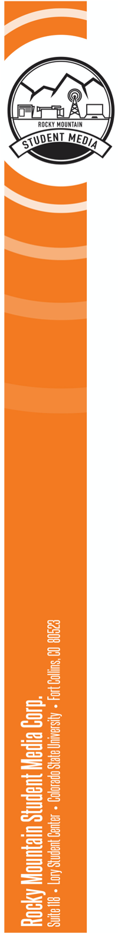

**The Rocky Mountain Collegian  
Assistant Photo Director**

The Assistant Photo Director is a leader who helps the Photo Director oversee and direct the operations of the Collegian’s photo desk. The Assistant Photo Director maintains a minor presence in the newsroom, is excited about photojournalism and is engaged in and dedicated to the overall production of content for the Collegian’s digital and print products. The position **requires a commitment of 8 hours per week of work-related duties** (with around 2-4 hours in the summer). We are hiring one position with the goal of training whoever is hired in the basic duties of the Photo Director.

**The ideal candidate possesses the following qualities:**

* Possesses a strong grasp of photography principles.
* Has a strong understanding of photojournalism, and the differences between a photographer and a photojournalist.
* Thinks ahead and plans for success.
* Responsive to content changes as assignments change throughout the day.
* Strong organization skills and an ability to coordinate a team.
* Has a strong understanding of, or willingness to learn, photojournalism ethics.
* Has a strong understanding of, or willingness to learn, copyright and communications law principles as it relates to using and editing images.
* Has a basic understanding of AP style and micro-editing.
* Prioritizes teamwork to maintain an inclusive and professional culture on the desk.
* Understands the importance of presenting information as a cohesive package, and has a strong desire to work with other content producers in order to accomplish a shared goal of multi-media presence.
* Strong communication skills and an ability to make decisions under pressure.
* Very skilled in Adobe Photoshop CS6, CC.
* Effectively balances time commitments outside of work.

**Main Responsibilities**

* Keeps photojournalists accountable for content production through the implemented feedback system as well as through direct communication.
* Works with the Photo Director to ensure the timely production of photos for print and digital platforms, including designated social media accounts.
* Manages photo requests and approves pitches for photo stories and standalones.
* Works with the other editors (primarily the Photo Director, Editor in Chief, Design & Social Editor and Print Editor) to ensure each story is accompanied by visual content.
* Takes responsibility for cover photos, focus photos, and all photo stories.
* Communicates frequently with managing editors about problems that could disrupt production.
* Edits and reviews photos to ensure they are ready for publication at deadline.
  + - * Ensures that photographers have access to events that require press credentials.
* Thinks ahead to plan visuals for special editions.
* Communicates with the Photo Director weekly to discuss if any reporters are not filling out visual requests correctly.

**Managerial Responsibilities**

* Holds weekly planning meetings for the photography desk.
* Plans ahead by keeping in mind the success of the publication as a whole.
* Provides feedback to photojournalists after assignments are submitted.
* Encourages and nurtures new photojournalists and coaches skills.
* Keeps photojournalists accountable for photography and reporting skills.
* Pitches new and creative ideas to engage with the readers through photography.
* Keeps track of visual requests to make sure all photo assignments are completed
* Works at print production to ensure photos are ready for print gallery
* Holds one weekly office hour to be accessible to photojournalists.

**Compensation**: Compensation will be $15 per hour. Employees are encouraged to apply for University work study. Employee Benefit information through Colorado State can be found on HR’s Website: https://hr.colostate.edu/current-employees/benefits/. Colorado State University may conduct background checks on all final candidates.

*Rocky Mountain Student Media Corporation is committed to increasing the diversity of our staff and providing a culturally responsive work environment. We encourage applications from people of all backgrounds and abilities. While RMSMC is an independent corporation from the University, we embrace Colorado State’s Principles of Community to guide us in our educational mission.*

**To apply**: Submit a resume, cover letter and three relevant portfolio clips to aseibel@collegian.com by with the subject line: “Collegian 2023-2024 Application: Assistant Photo Director.” Interviews will be scheduled and held by the Editor-in-Chief. Be prepared to answer questions regarding the attributes and responsibilities listed above. Position will be open until filled, with a final deadline of May 5. Priority application due April 23.